20MCA136 – NETWORKING & SYSTEM ADMINISTRATION LAB Dept. of Computer Applications

# NETWORKING & SYSTEM ADMINISTRATION LAB

**Name: MELBIN M P**

**Roll No: 19**

**Batch: S2 RMCA B Date: 05-05-2022**

**Experiment No: 8**

# Aim

Write a shell script to print the basic details.

# Procedure

#!/bin/bash

echo "Enter the name:" read name

echo "Enter the Rollno:" read rno

echo "Enter email id:" read email

echo "enter the place:" read place

echo "***********************************" echo "The name is :" $name

echo "The name is :" $rno echo "The email id is:" $email echo "The place is:" $place

Output

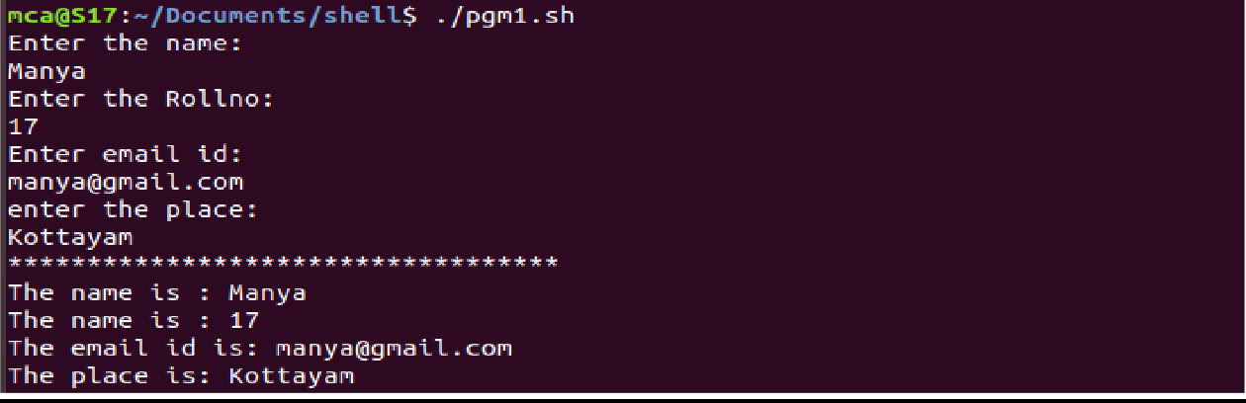

Amal Jyothi College of Engineering, Kanjirappally